Peace Pipe Ceremony
Ceremony of Peace and Thanksgiving to the Great Spirit
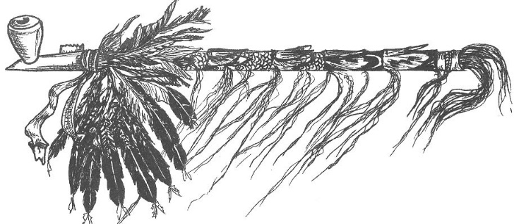
Overview: This ceremony/prayer service can be used either as a stand-alone ceremony or incorporated into a larger ceremony. It could be performed as a sunrise ceremony or as an end of day ceremony. It can be performed around a council fire or a smaller campfire as desired.
A ceremonial pipe is a symbolic central part of this ceremony. The person handling the pipe can decide whether to smoke it for authenticity, or just make motions (or somehow simulate) as if he is smoking it.
Participants:
- Chief: Leader of ceremony.
- Medicine Man or Assistant Chief: Co-leader of ceremony.
- Sachem or Elder: Ceremonial dance of thanks for fire.
- Drumbeater

Relevant Ceremonial Pieces: You may wish to incorporate this ceremony with other ceremonial components to form your full ceremony. The following are basic suggestions. Your creativity is your limit.
- Council Fire Opening & Lighting
- Inductions, Graduation, End of Year or Other Council Fire Ceremony
- Officer Inductions
- Special Awards
- Ceremonial Closing

CEREMONY
Scene | (Council fire is already burning.
Drumbeater | (Leader signals drumbeater when to start / stop while (if) the Longhouse (now) gathers around this fire.
Chief | Great Spirit, our heavenly Father, Creator of all that is nature, we humbly come to you in the midst of nature’s splendor to thank you that we as Americans are free to worship as we please and to enjoy all that is nature… it’s mountains, it’s valleys, it’s lakes, it’s streams, and the living things that dwell within… we ask that you that someday, all the world may be at peace and that all people be free to enjoy nature’s abundance. We ask you that we be guided to protect this priceless heritage that we, in America, are privileged to enjoy.
Medicine Man | From the Omaha Tribal Prayer, please repeat after me… “Father, a needy one / stands before thee / I that speak am he.”
Medicine Man | The Native Americans Indians believe in the Creator, He showed himself through the Spirit of Nature, through animals, birds, earth, children, sun, fire, and hunting.  The Native Americans have deep faith in the Creator and their Mother Earth. When they need the sun to ripen their crops, they called on the Spirit of the Sun. When children were ill, they called to the Spirit that heals children and give strength. In times of great calamity, like drought, flood, disease; the Medicine Man was called upon. Through him, the Creator showed his power.  Ceremony plays an important part in our own beliefs as well as the beliefs of the Native American Indians.
Chief | Our ceremony now is a peace pipe ceremony. The pipe is a symbol of peace and honor for Native Americans.  But first, we see that our council fire is burning well… We give thanks for this… (Sachem Indian Name) our Sachem now shows our thanks to the Great Spirit for this gift of fire and warmth.
Sachem | (Does ceremonial dance in a complete circle around fire)
Medicine Man | (As the Sachem finishes performing dance, steps forward with peace pipe held high in both hands and walks to the edge of the fire. When Sachem has finished, bends to the fire and lights the pipe, taking/blowing several puffs for effect.)
Medicine Man | (Lift pipe high again) To Wakonda, the one Great Spirit, that his wisdom be with us. (Shout Longhouse salutation several times)
ALL | Amen.
Medicine Man | (Blowing smoke and pointing the pipe stem to Mother Earth) To Maka-Ina, Mother Earth, that she may send us food.
ALL | Hear us Mother Earth, Amen.

 | (The Medicine Man can stand in one position for the following 4 Directions or walk to each Direction point around the fire as he performs the following:)
Medicine Man | (Blowing smoke and pointing the pipe stem to the West) To Wiypoeyata, the Sunset Wind, that he come not bring his strength upon us.
ALL | Hear us Sunset Wind, Amen.
Medicine Man | (Blowing smoke and pointing the pipe stem to the North) To Waziyata, the Winter Wind, that he not harm us with his cold.
ALL | Hear is Winter Wind, Amen.
Medicine Man | (Blowing smoke and pointing the pipe stem to the East) To Wiyohinyanpata, the Sunrise Wind, that he trouble us not with his rain.
ALL | Hear us Sunrise Wind, Amen.
Medicine Man | (Blowing smoke and pointing the pipe stem to the South) To Ito-Kagata, the Hot Wind, that he strike us not with his fierce heat.
ALL | Hear is Hot Wind, Amen.
Medicine Man | (Hold pipe high in both hands again) The peace of the Great Spirit is high. Your peace we ask, not for us alone, but that we might give it to all people. May the peace of the forest, and the joy of the winds be in our hearts today and always. Let us share a sign of peace with one another.
ALL | (Shake Hands with those around you)
Chief | Great Spirit, those before you have witnessed a ceremony of the Peace Pipe today. Let them learn to bring peace to their fellow man. I now recite the Kiowa Indian version of our Lord’s Prayer: (Or have group repeat in parts)  Great Spirit, you are our Father and who lives above us. Beyond the clouds and sky, Worship is your name. And we want to be done here among us, let it be as it is in heaven above. Give us our bread day by day. Forgive us our wrong as we go on. Forgiving those who wrong us. Lead us away from doing wrong. And take away trouble from our hearts. Set us free from evil, for all belongs to You. All praise and wonder we give to You. All praise and wonder we give to You. From this day forth and forever more.
Chief | (With sign language) And now, may the Great Spirit, of all good spirits, be with you now, and forever more.
ALL | Amen.
Drumbeater | (Drumbeats while/if people exit)
 | END OF CEREMONY

